CHINMAYA INTERNATIONAL RESIDENTIAL SCHOOL
COIMBATORE

SAMPLE PAPER – 2010
CLASS : 1st IB SUBJECT: BIOLOGY

- What is the composition of the backbone of DNA?
  - Alternating sugar and phosphate molecules
  - Complementary base pairs
  - Alternating sugar and base molecules
  - A polysaccharide
ANSWER

- Which of the following best describes a virus?

A. | Non-cellular | Nucleic Acid | No protein
B. | Cellular | Nucleic Acid | No protein
C. | Non-cellular | Nucleic Acid | Protein
D. | Cellular | Nucleic Acid | Protein

ANSWER

- Which structure (s) is /are present in both animal cells and plants cells?

  - Plasma membrane
  - Ribosomes
  - Cell wall

  - I only
  - I and II only
ANSWER
  - II and III only
  - I, II and III

- How many ATP molecules (net yield) are produced per molecule of glucose as a direct result of glycolysis?
  - 2
  - 4
  - 10
  - 38
ANSWER

- Which phases of mitosis are shown in diagrams I and II?
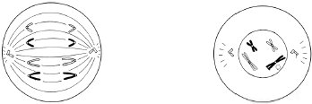
I II

 | I | II
A. | Metaphase | Prophase
B. | Metaphase | Telophase
C. | Anaphase | Prophase
D. | Anaphase | Metaphase

ANSWER

